REPORT TO THE OWEN SOUND POLICE SERVICES BOARD

Subject: 2024 **Use of Force Annual Report**

To: Chair and Members of the Owen Sound Police Services Board

Date: 18 February 2025

# **RECOMMENDATION(S):**

For Information

# Report:

## Reporting Use of Force

As a requirement under Ontario Regulation 926 of the Police Services Act (PSA), a Use of Force report must be submitted when a member of a police service:

* draws a handgun in the presence of a member of the public;
* points a firearm at a person;
* discharges a firearm;
* uses a weapon on another person;
* draws and displays a conducted energy weapon (CEW) to a person with the intention of achieving compliance;
* points a CEW at a person;
* discharges a CEW; or
* uses force on another person that results in an injury requiring medical attention.

A modernized Use of Force report was implemented on January 1, 2023, based on amendments to use of force reporting requirement in Regulation 926 made in November 2022. Amendments include submission requirements related to CEWs; annual review of use of force procedures and training; and publication of annual reports to the police services board analyzing the data from the reports and identifying any trends.

Information about a use of force event that is captured in the standardized provincial report includes data on citizen race, gender, and age as perceived by the officer at the time of use of force, the type of force used, any weapons involved, injuries sustained, etc. Reporting and analysis can be used to assess individual and group training needs, policy and procedure requirements, and racial disproportionalities and disparities.

## Race and Identity-Based Data Collection

Ontario’s Anti-Racism Act (ARA), 2017, establishes transparent and sustainable mechanisms to identify and eliminate systemic racism and advance racial equity in Ontario. As a requirement of the ARA, police services collect race-based data on the Use of Force report in a manner compliant with the Anti-Racism Data Standards (ARDS), which outline how organizations must collect, manage, analyze and report on information collected under the authority of the ARA. This oversight and accountability is in place to monitor for impacts and trends to: advance racial equity; improve policy and service delivery; and increase transparency and trust.

In recent years, there have been increasing demands from community groups and the public for police to collect data stemming from citizen-police interactions, and directions on the collection of race/ethnicity data to police agencies from civilian oversight organizations, commissions and agencies, as well as provincial governments. In July 2020, Statistics Canada and the Canadian Association of Chiefs of Police (CACP) released a joint statement announcing their commitment to working on the collection of data on the Indigenous and racialized identity of all victims and accused persons as it pertains to criminal incidents through the Uniform Crime Reporting (UCR) Survey.

In October 2023, the Ontario Association of Chiefs of Police (OACP) approved a provincial Race and Identity-Based Data (RIBD) Framework, as a starting point for all Ontario police services to address issues related to RIBD. It includes foundational practices in data collection, data analysis, policy development, reporting and leadership strategies to equip police services with the knowledge, skills and capacity to improve outcomes for all Ontarians. The OACP’s multi-stakeholder approach is drawing on expertise from academia, police governance, Ontario Human Rights Commission, Ontario Anti-Racism Directorate, and others including an Expert Working Group from Peel Regional Police, Toronto Police, Ontario Provincial Police, and the RCMP. Next steps include continuation and facilitation of future iterations of this work, exploration of an Indigenous Data strategy, and creation of a centre of excellence.

## 2024 Use of Force Annual Report

It is important to note that numbers in this annual report are not always a 1:1 ratio, for example, multiple officers may each submit a report on one or more types of force used during the same incident on the same individual, or one officer may submit a report on one or more types of force used on multiple individuals in the same incident. Each officer using reportable force must submit a report and include their perception of race, age, and gender of each subject and the type(s) of force.

* There were 31 Use of Force reports submitted in 2024, involving 25 unique incidents, 24 unique persons, and three animals. The number of subjects involved in any one incident varied from zero to four. This is relatively consistent with 2023, with 24 unique persons that required officers to use reportable force.
* With 18,886 occurrences dispatched for OSPS in 2024, the use of force reported in 25 incidents represents 0.1% of all events. Officers are trained in various types of force, and de-escalation techniques such as communication, containment, teamwork, repositioning, and distance.
* In 2024, there were five unique incidents where 2 officers each submitted a report on the same individual.
* Officers’ perception of the person’s race involved in the use of force events was recorded as White 17 times, Middle Eastern one time, and Indigenous 2 times in 2024.
* Of the 24 individuals described in use-of-force reports in 2024, these subjects were perceived as being male 20 times and female 4 times.
* 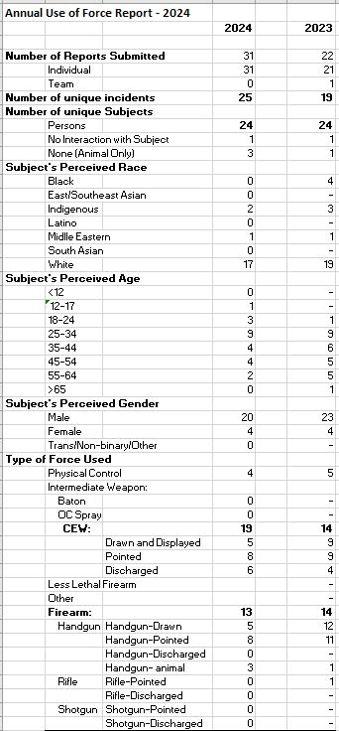Physical control (e.g. escort technique, grounding, pinning) was used and reported 4 times in 2024, similar to the previous year. Incidents involving physical control are not required to be reported, unless the subject requires medical care or a report is triggered by a greater level of force used in the same incident.
* In 2024, a Conducted Energy Weapon (CEW) was drawn, displayed, pointed, and/or discharged 19 times, as compared to 14 times in 2023.
* A firearm was reported drawn, pointed, and/or discharged 13 times in 2024, compared to 14 in 2023. In 2024, a firearm was drawn, pointed or discharged in:
  + 3 animal complaint incidents in which the firearm was discharged on an animal only;
  + 1 incident in which the officer drew a firearm in clearing an unknown area; no subject was present;
  + 3 incidents each with one officer and 1 subject (two violent crimes, and one weapons call);
  + 4 incidents where multiple officers responded to deal with one subject (2 violent crimes, 1 barricaded subject, 1 disturbance call);
  + 1 incident in which multiple subjects were present.

# Financial/Risk Implication(s):

Although exceedingly rare, few calls for service result in a provincially reportable use of force event; however, an event can have large impacts/risk on citizens, police, and communities.

# Operations Plan:

Valuing “Integrity” by serving with respect, honesty, accountability, and transparency is reflected in this annual reporting of the Service’s use of force.

# Attachment(s):

Nil

# SUBMITTED BY:

Inspector Jeff Fluney

Constable Carlo Obillos, Training Officer

Marg Gloade, Strategic Analyst